**ASSIGNMENT 3**

|  |  |
| --- | --- |
| **Assignment date** | 16.10.22 |
| **Student Name** | Prapthi.N |
| **Roll No** | 821319104024 |
| **Maximum Marks** | 2 Marks |

1.Create a bucket in IBM Object storage.

2.Upload 5 images to object storage and make it public .Write HTML code to displaying all the 5 images.

3.Upload a CSS page to the object storage and use tha same page in your HTML code.

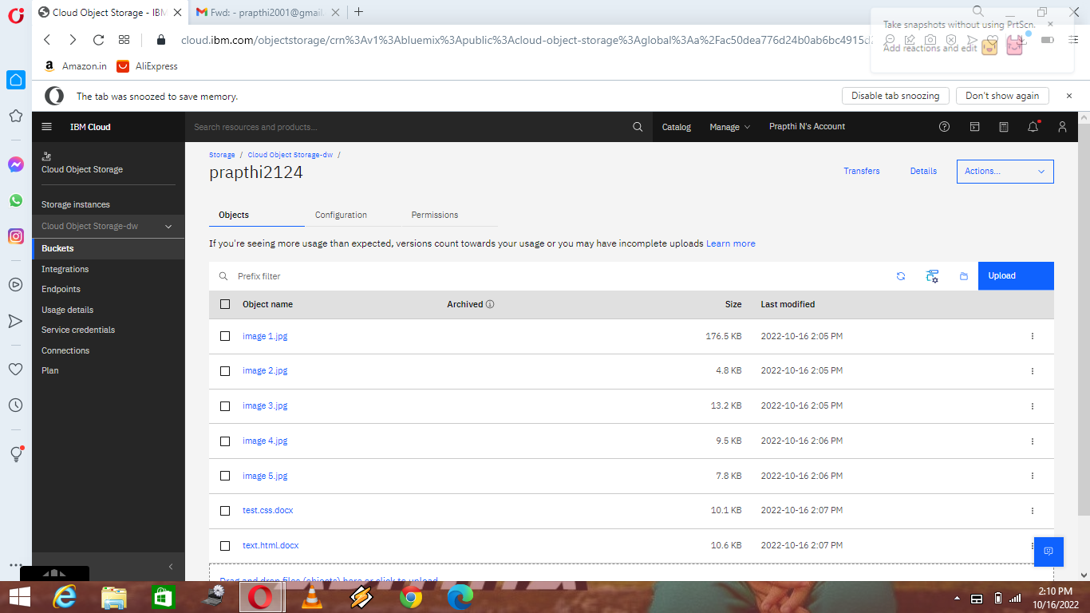

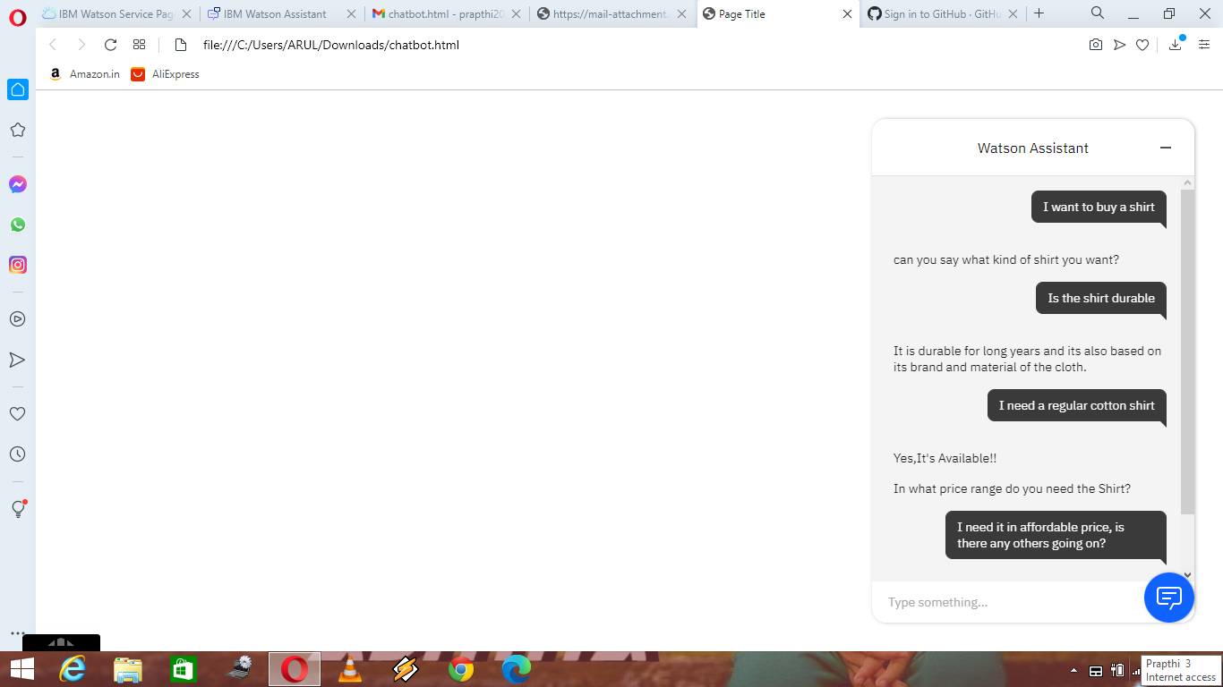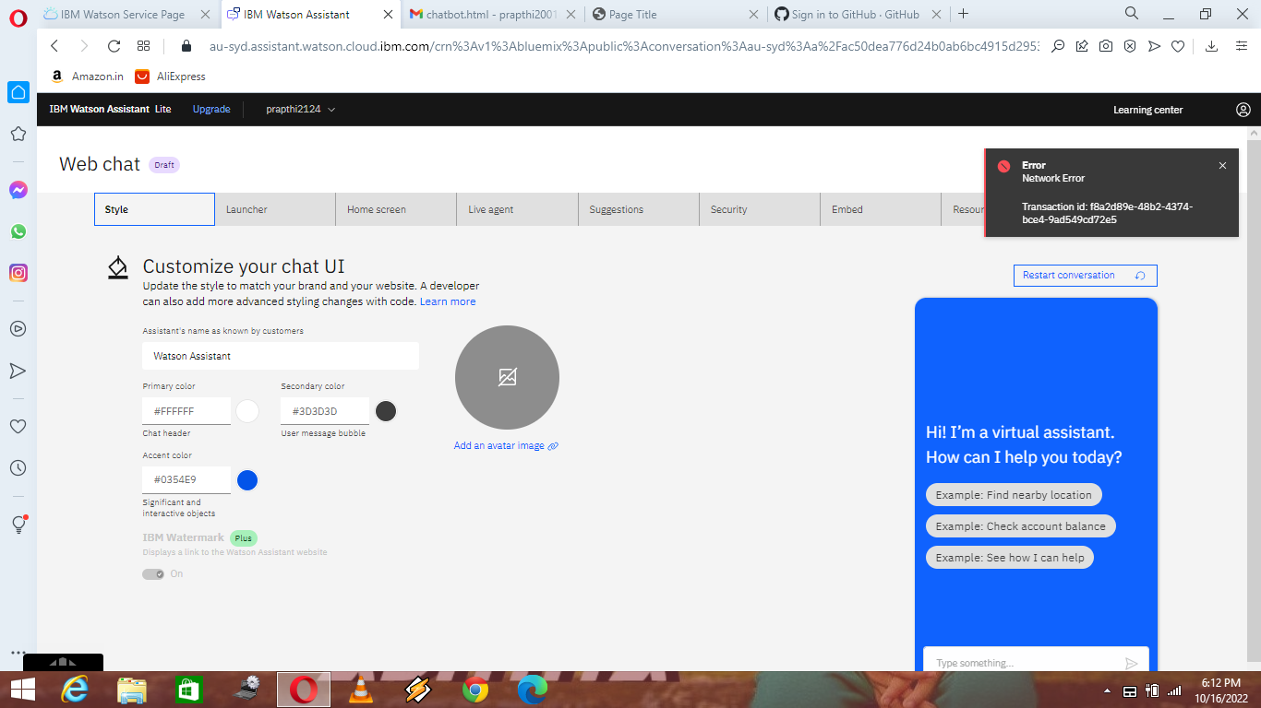4.Design a Chatbot using IBM Watson Assistant for online shopping.

5.Create Watson Assistant Service with 10 steps and 3 conditions. Load that script in HTML Page.

